DESIGN AND PERFORMANCE ANALYSIS OF FREQUENCY RECONFIGURABLE PLANAR MONOPOLE ANTENNAS FOR WIRELESS APPLICATIONS

Dr. prof Chetan S, Rakshitha R, Varshitha N N, Vasudev M N, Vennala R L

¹ Dr. prof Chetan S, Assistant professor, E&CE, SJM Institute of Technology, Chitradurga, Karnataka, India
² Miss. Rakshitha R, Student, E&CE, SJM Institute of Technology, Chitradurga, Karnataka, India
³ Miss. Varshitha N N, Student, E&CE, SJM Institute of Technology, Chitradurga, Karnataka, India
⁴ Mr. Vasudev M N, Student, E&CE, SJM Institute of Technology, Chitradurga, Karnataka, India
5 Miss. Vennala R L, Student, E&CE, SJM Institute of Technology, Chitradurga, Karnataka, India

ABSTRACT

This paper presents the design and analysis of a frequency-reconfigurable planar monopole antenna intended for modern wireless communication systems. The antenna structure is engineered to operate at multiple frequency bands by integrating switching elements such as PIN diodes/varactors, which dynamically modify the current distribution on the radiating patch. By reconfiguring its operating frequencies, the antenna supports various wireless standards including WLAN, Wi-Fi, LTE, and 5G sub-6 GHz. A compact planar monopole geometry is optimized to achieve wide impedance bandwidth, stable radiation patterns, and good gain performance across all selected modes. The design is simulated using electromagnetic modeling tools to evaluate key parameters such as S-parameters (S11), radiation pattern, VSWR, gain, and efficiency. The results confirm that the antenna provides flexible frequency switching, maintains strong performance, and is suitable for integration into portable and multi-standard wireless devices. This work highlights the effectiveness of reconfigurable antenna technology in addressing the increasing demand for compact, multifunctional, and energy-efficient wireless communication systems.

Keyword : - Frequency reconfigurable antenna, Planar monopole antenna, Wireless communication, PIN diode switching,,Varactor based tuning, Multi-band operation, Impedance bandwidth, S-parameters (S11), Radiation pattern, Antenna gain, Reconfigurable systems, Electromagnetic simulation, Compact antenna design.

INTRODUCTION

The rapid growth of modern wireless communication technologies has increased the demand for compact, efficient, and multifunctional antennas capable of operating over multiple frequency bands. Conventional fixed-frequency antennas are no longer sufficient because wireless devices now support various standards such as WLAN, LTE, Wi-Fi, Bluetooth, and emerging 5G services. This has led to the development of frequency reconfigurable antennas, which can dynamically adjust their operating bands to accommodate different communication requirements without the need for multiple antenna elements. Among the various antenna types, planar monopole antennas have gained significant attention due to their simple geometry, low profile, lightweight structure, and ease of integration into portable devices. By embedding switching components such as PIN diodes or varactor diodes, the electrical length of the antenna can be altered, enabling real-time control of resonant frequencies. This reconfigurability not only improves spectrum utilization but also enhances device performance by reducing interference and power consumption. This paper focuses on the design and performance analysis of a frequency reconfigurable planar monopole antenna tailored for multi-standard wireless applications. The antenna structure is optimized for compactness, wide bandwidth, and stable radiation characteristics. Comprehensive electromagnetic simulations are carried out to evaluate key performance parameters including return loss, VSWR, radiation pattern, gain, and efficiency across different reconfigured states.

The study demonstrates that the proposed reconfigurable antenna offers flexible frequency tuning while maintaining desirable radiation characteristics, making it a strong candidate for integration into next-generation wireless and IoT devices. The results highlight the potential of reconfigurable antenna technology in addressing the evolving needs of modern communication systems.

  - Components
1. Radiating Patch
2. Ground Plane
3. Substrate Material
4. Switching Elements
5. Biasing Circuit
6. Feed Mechanism
7. Matching Network
8. SMA Connector
9. Simulation Tools
10. Testing Equipment

  - Methodology
The methodology for designing and developing a microstrip patch antenna with a slot array for S-Band and C-Band wireless applications begins with determining the required operating frequencies and performance targets such as bandwidth, gain, and efficiency. A suitable dielectric substrate is then selected based on parameters like dielectric constant and thickness, as these strongly influence antenna behavior. Using standard microstrip patch design equations, the initial patch dimensions are calculated to achieve resonance in the S-Band. To enable dual-band performance, slots of specific shapes and sizes are introduced into the patch; these slots are strategically positioned to excite additional resonant modes that extend operation into the C-Band. A 50-ohm feedline is designed to ensure proper impedance matching, followed by detailed electromagnetic simulations using tools such as CST or HFSS. Parametric optimization is carried out by adjusting patch dimensions, slot geometry, ground plane size, and feed position to achieve strong S11 performance at both bands. If required, a slot array configuration is developed to enhance gain and directional radiation. The optimized antenna is then fabricated using PCB technology and tested using a Vector Network Analyzer and anechoic chamber. Finally, the measured results are compared with simulated data to validate the design and confirm its suitability for S-Band and C-Band wireless communication applications.

2. BLOCK DIAGRAM

A block diagram for a frequency reconfigurable planar monopole antenna system for wireless applications generally involves the following key components and their interactions switching state(ON&OFF). Wireless Transceiver/RF Front-end is component generates the RF signal to be transmitted or receives the signal intercepted by the antenna. It connects to the antenna system via a feed line. Antenna Feed Network is typically a microstrip line that provides the signal to the radiating element. Frequency Reconfigurable Planar Monopole Antenna The core component, printed on a substrate (e.g., FR-4 or Rogers RT5880), which can change its resonant frequency by altering its electrical length or geometry.
Switching Mechanism enables the physical change in the antenna's structure Control Unit/DC bias a circuit (often integrated on the same substrate) that provides the necessary control signals and DC bias voltage to the switches.

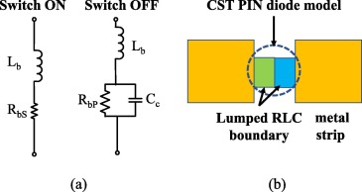

Fig-1: Block diagram for ON and OFF state

1.1 1. Switch ON State (Forward-Biased)
When the PIN diode is ON, it behaves like a low-resistance conductor.
It is modeled as:
R_bS → very small resistance (1–5 Ω)
L_b → a small package inductance (≈ 0.5–1 nH)
Effect: The diode acts almost like a short circuit, connecting or activating a stub/slot of the antenna → enabling a specific frequency band.
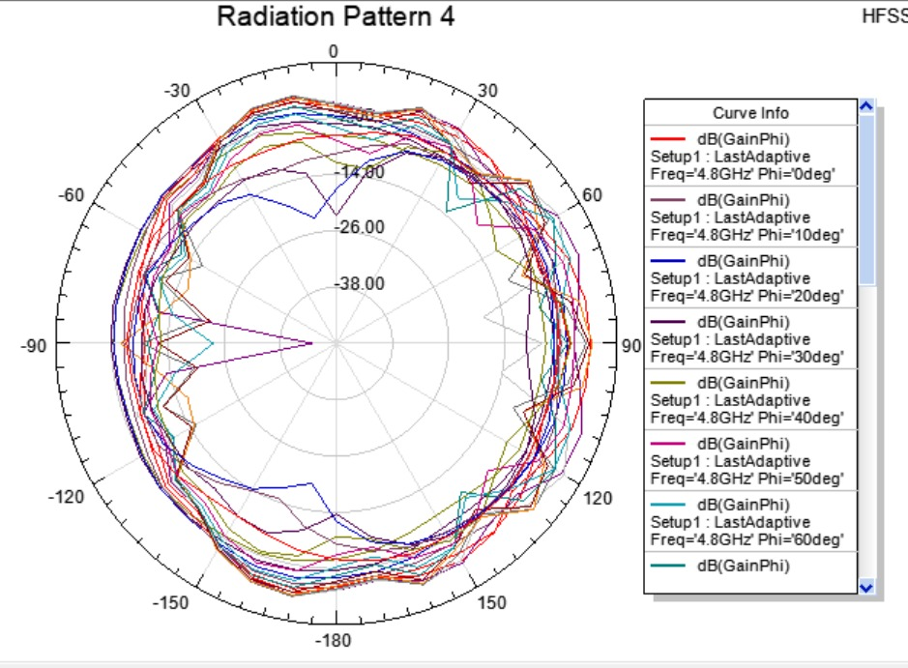

Fig 1 : On state radiation Pattern.

2. Switch OFF State (Reverse-Biased)
When the diode is OFF, it behaves like a high-impedance device that blocks RF current.
It is modeled as:
R_bP → large resistance (kΩ range)
C_c → small junction capacitance (0.02–0.5 pF)
L_b → same series inductance as ON state
Effect: The diode acts like an open circuit.

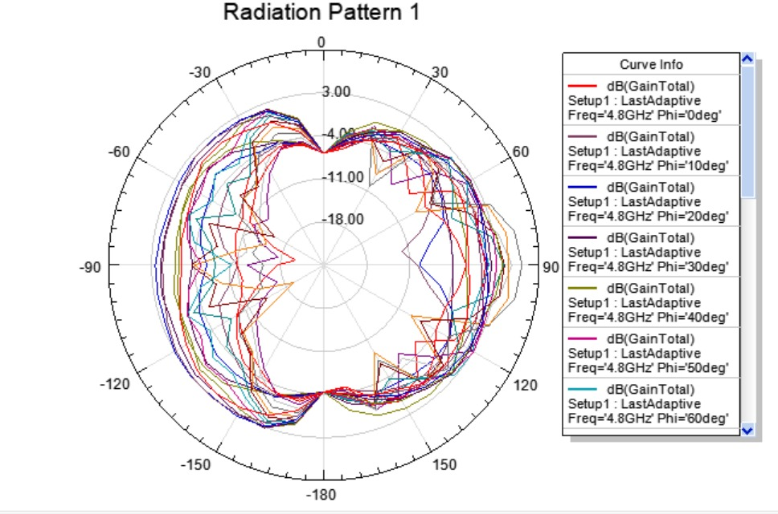
Fig 2 : Off state radiation Pattern.

  - 1. Switch ON State (Forward-Biased)

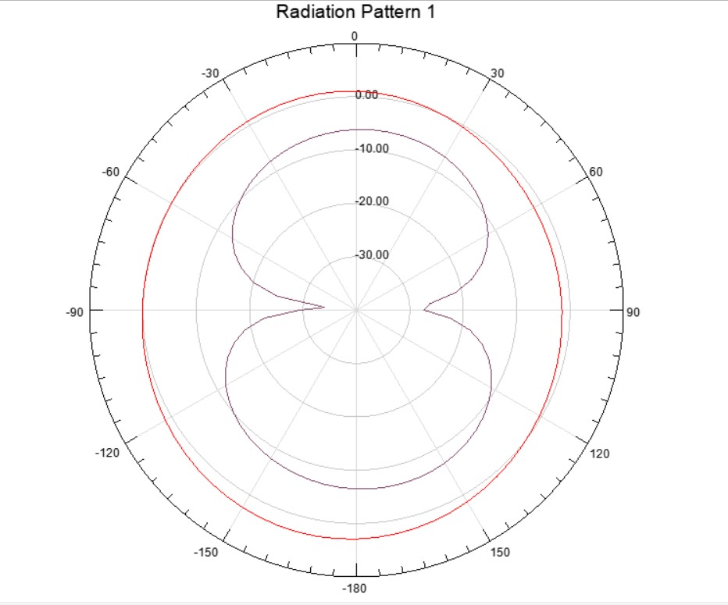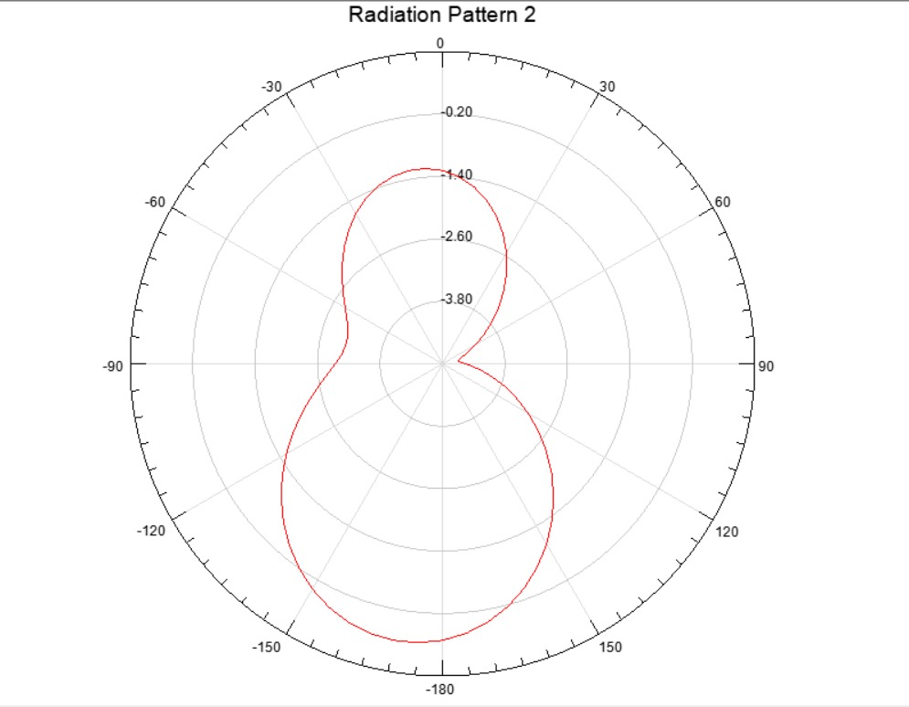
Fig 3: Two different radiation modes(ON), Radiation Pattern 1&2 is shown.

When the reconfigurable antenna’s switching element is turned ON, it activates an additional radiating path or modifies the effective length of the antenna. This causes the antenna to operate in two different radiation modes, which are represented by Radiation Pattern 1 and Radiation Pattern 2. both patterns show how the antenna behaves after switching ON, but at two different frequency states or two resonant modes enabled by the switch..
RADIATION PATTERN-1
- Stronger radiation occurs around 0° and 180°.
- The side directions (±90°) have deep nulls.
- The gain level spans roughly from 0 dB to –30 dB.,the shape indicates a higher-order mode with symmetrical lobes.
When the switch is ON, the antenna resonates at a specific frequency two opposite major lobes, directional radiation along the horizontal axis, reduced side radiation. This is typical when the antenna’s current distribution becomes symmetric after switching.
RADIATION PATTERN-2
The pattern becomes asymmetric and more directional. A dominant lobe appears around 180°, larger than other regions. Smaller lobe appears near 0°, Gain ranges from –1.4 dB to –3.8 dB. Side nulls shift slightly, indicating a different resonant behaviour. This shows another operating mode that appears after the switch is activated, the antenna radiates strongly in only one main direction, the lower hemisphere covers a broader area, the pattern becomes highly directional.
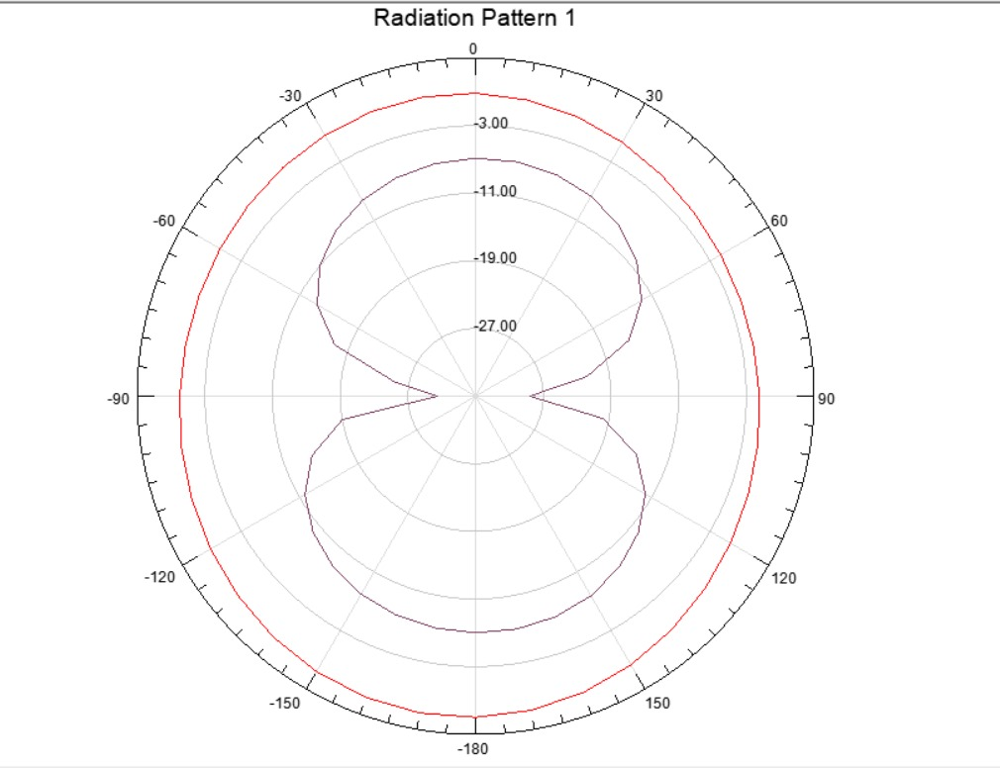
Fig4: Off state radiation Pattern

The radiation pattern shown in the image is a polar plot representing the gain of an antenna across different angles, the pattern has two main lobes, indicating maximum radiation in two opposite directions (approximately 0° and 180°). The gain values are shown in decibels (dB), ranging from a maximum around -3.00 dB to a minimum below -27.00dB. the antenna's radiation is intentionally suppressed or significantly reduced, often resulting in a much weaker or less defined pattern compared to the "on state".

Objective
The main objective of this work is to design, optimize, and analyze a compact microstrip patch antenna integrated with a slot array structure that can efficiently operate in the S-band (2–4 GHz) and C-band (4–8 GHz) frequency ranges. The antenna should achieve dual-band performance, enhanced bandwidth, improved radiation characteristics, and suitability for modern wireless communication systems. Enable multi-band or wideband operation to support various modern wireless communication standards (e.g., WLAN, WiMAX, LTE, 5G) with a single antenna, thereby reducing the need for multiple static antennas, Analyze and optimize key performance metrics, including return loss, impedance matching (VSWR), gain, radiation efficiency, and radiation patterns, across all reconfigured states. Achieve size miniaturization and low cost, making the antenna suitable for easy integration into compact, portable, and handheld wireless devices Minimize signal interference between different frequency bands by providing high isolation and controlled frequency selectivity.
2.1 Importance and Motivation
The increasing demand for high-performance wireless communication systems in modern applications such as radar, satellite links, weather monitoring, aviation, and high-speed data transmission has created a strong need for compact, efficient, and multi-band antennas. Microstrip patch antennas have become one of the most preferred choices due to their advantages like low profile, light weight, easy fabrication, and compatibility with planar circuits. However, conventional patch antennas often suffer from limitations such as narrow bandwidth, single-frequency operation, and moderate gain. To address these challenges, the integration of a slot array structure into the microstrip patch provides an effective approach for achieving improved bandwidth, enhanced radiation characteristics, and dual-band or multi-band performance. The S-band (2–4 GHz) and C-band (4–8 GHz) are widely used in critical communication systems including marine radar, satellite communication, and wireless networking, making it essential to design antennas that can operate efficiently in these bands.
The motivation of this work stems from the need to develop a compact, low-cost, and high-performance antenna capable of supporting both S-band and C-band operations within a single structure. By introducing carefully optimized slots and array techniques, the antenna can achieve better impedance matching, wider operating bandwidth, and higher gain while maintaining a small form factor. Such antenna designs contribute significantly to next-generation communication systems, offering improved reliability, versatility, and integration with modern RF front-end circuits.

2.2 Working
The working of a microstrip patch antenna with a slot array is based on controlling the surface currents and resonance behavior of the patch to achieve operation in the S-band (2–4 GHz) and C-band (4–8 GHz). The slot array is used to create additional resonant paths, modify current distribution, and improve radiation characteristics.
VSWR(voltage standing wave ratio) 2.1:
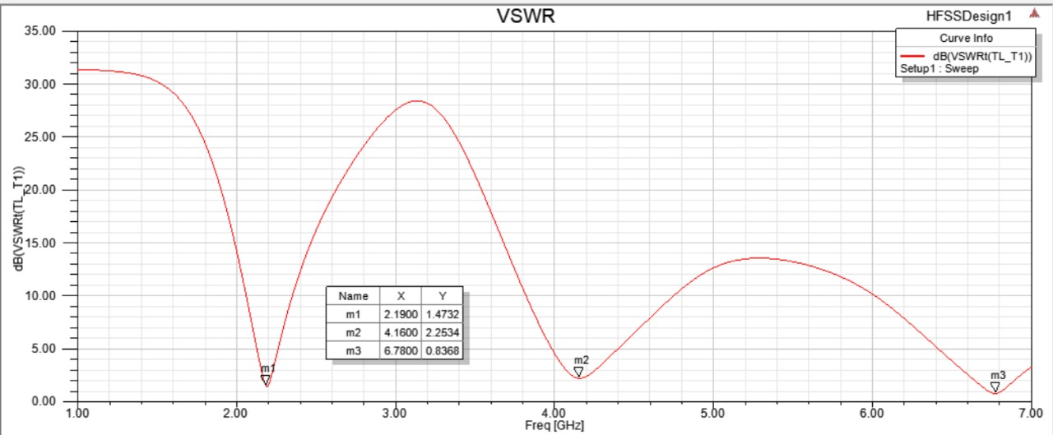
Fig1: VSWR in ON state
(m1, m2, m3) indicate specific frequency and VSWR values on the curve:
m1: 2.1900 GHz, 1.4732 dB, m2: 4.1600 GHz, 2.2534 dB, m3: 6.7800 GHz, 0.8368 dB.

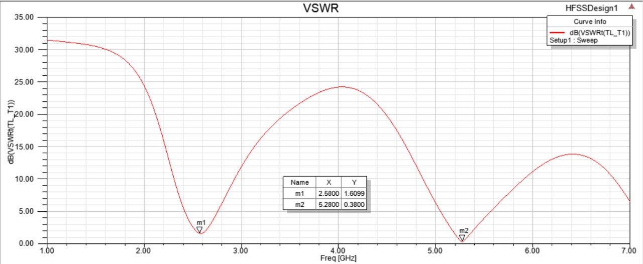
Fig2: VSWR in OFF state
m1: 2.5800GHz, 1.6099 dB, m2: 5.2800GHz, 0.3800 dB
VSWR 2.2:
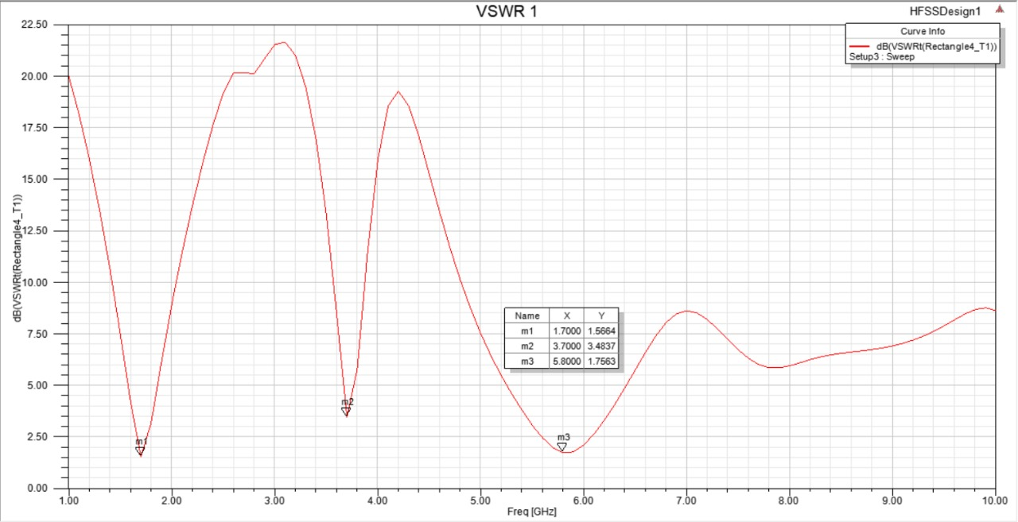
Fig3: VSWR in ON state
m1: At a frequency of 1.7000 GHz, the VSWR is 1.5664 dB.
m2: At a frequency of 3.7000 GHz, the VSWR is 3.4837 dB.
m3: At a frequency of 5.8000 GHz, the VSWR is 1.7563 dB.

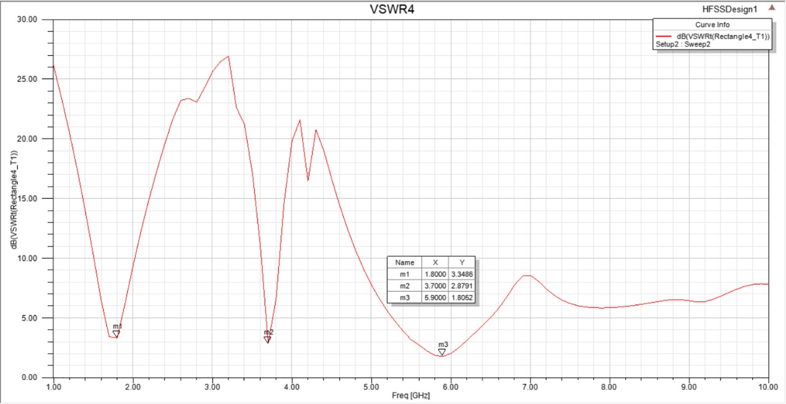
Fig4: VSWR in OFF state
m1: At 1.8000 GHz, the VSWR value is 3.3486 dB.
m2: At 3.7000 GHz, the VSWR value is 2.8791 dB.
m3: At 5.9000 GHz, the VSWR value is 1.8052 dB.

3. Applications
Frequency reconfigurable planar monopole antennas are crucial for modern wireless communication systems because they can dynamically adjust their operating frequency to support multiple communication standards within a single, compact physical structure. This adaptability allows for efficient use of the limited spectrum, reduces interference, and minimizes the need for multiple fixed-frequency antennas in a single device, thereby saving space, cost, and design complexity. Specific applications for this technology include:
- Wireless Local Area Networks (WLAN): Enabling devices to seamlessly switch between different Wi-Fi bands (e.g., 2.4, 5.2, and 5.8 GHz) for optimal connectivity.
- Mobile Communication (4G/5G): Supporting operation across various cellular bands, including LTE, UMTS, and sub-6 GHz 5G frequencies, in portable devices like smartphones and tablets.
- Cognitive Radio Systems: Allowing devices to intelligently sense and switch to unused frequency bands in real-time, thereby maximizing spectrum efficiency and avoiding interference in congested environments.
- Satellite Communication: Providing versatility for systems that need to communicate across multiple satellite bands for reliable operation in various conditions.
- Internet of Things (IoT) Devices: Offering low-power, adaptable solutions for the vast array of connected devices in smart cities and other IoT networks that may need to operate on different communication protocols.
- Military and Radar Applications: Offering enhanced radar performance, improved signal detection, and flexible communication in complex or dynamic environments, often in unmanned aerial/surface vehicles (UAVs/USVs).

Design process
- Antenna Structure: Design a base antenna, such as a microstrip patch or monopole, with a specific substrate (e.g., FR-4) and dimensions to achieve a desired frequency range.
- Reconfigurability Mechanism: Introduce slots in the antenna structure to be filled with switches.
Integrate active or passive switching components like PIN diodes or lumped RLC elements into these slots. The ON/OFF state of these switches is controlled by external signals.
- Switching Logic: The combination of ON and OFF states of the switches determines the effective length or path of the current on the antenna structure, which in turn alters the resonant frequencies.
- Miniaturization: To create a compact antenna, techniques like modifying the ground plane or using a specific geometric shape (e.g., fractal or novel shapes) can be employed.
- Feed Network: An appropriate feed line, such as an inset microstrip line, is designed to provide good impedance matching for the different operating bands.

Analysis process Simulation:

The design and analysis of frequency reconfigurable planar monopole antennas involves integrating active switching elements into the antenna's structure to dynamically alter its operating frequency. The analysis process relies heavily on Electromagnetic (EM) simulation software to model the different antenna states and evaluate key performance metrics.

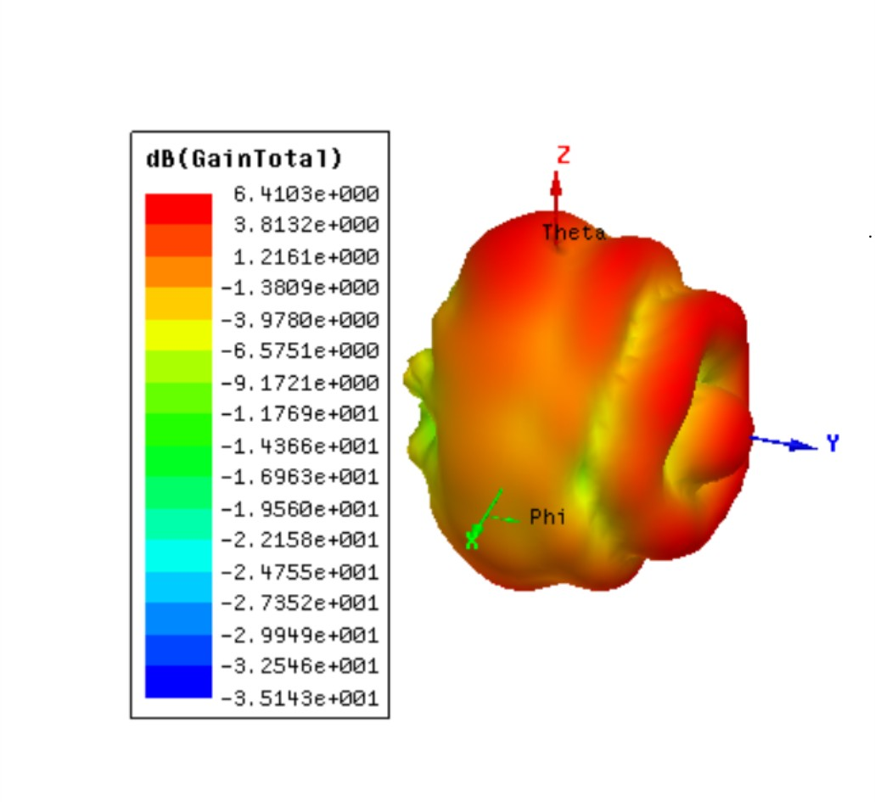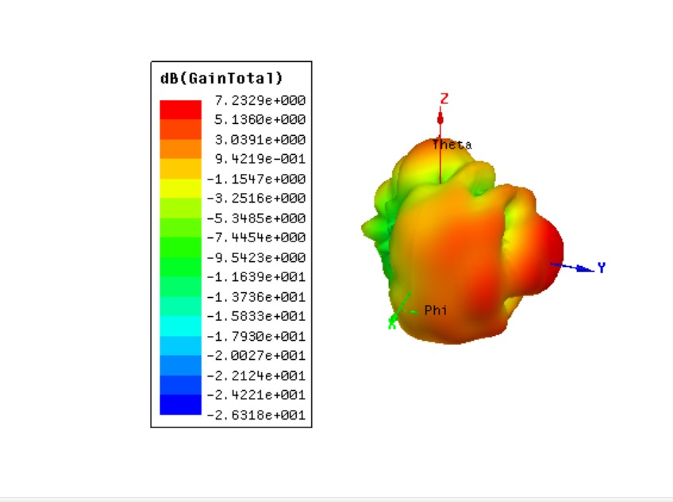
Fig: ON state Db(GainTotal) Fig: OFF state Db(Gain Total)

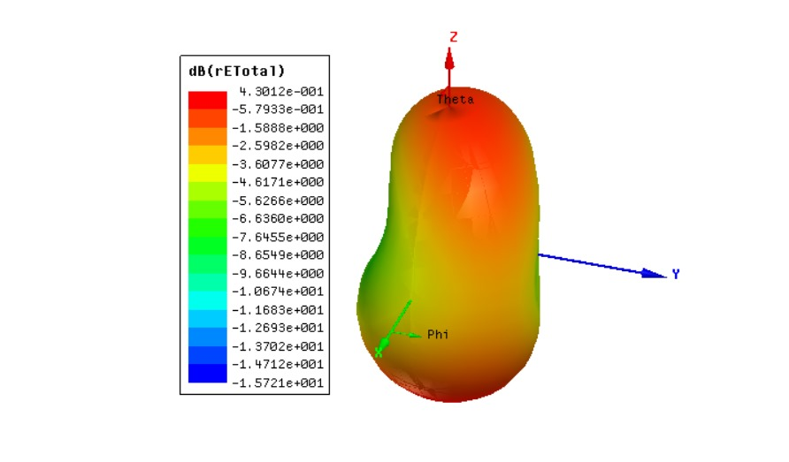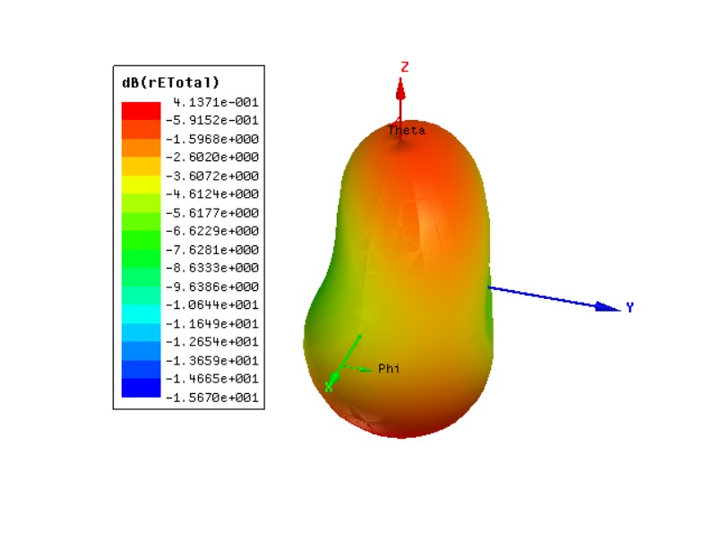
Fig 6: ON state 3D polar plot Fig7: OFF state 3D polar plot

3.1 Fabrication process
* Substrate selection: A suitable substrate material is chosen, such as FR-4 or Rogers Duroid, which determines the antenna's size and performance.
* Fabrication: The antenna is fabricated on the substrate using methods like photolithography to create the metallic patch or monopole structure.
* Switch integration: PIN diodes are placed at specific locations on the antenna structure to act as the switching elements.
* Biasing circuit: A biasing circuit is designed and fabricated to provide the DC voltage needed to control the PIN diodes. This circuit is crucial for isolating the DC control signal from the RF signal.
* Testing: The fabricated prototype is tested to validate the simulation results. Measurements of return loss, radiation pattern, and gain are performed across all operating frequencies and compared with the simulation.
* Substrate selection: A suitable substrate material is chosen, such as FR-4 or Rogers Duroid, which determines the antenna's size and performance.
* Fabrication: The antenna is fabricated on the substrate using methods like photolithography to create the metallic patch or monopole structure.
* Switch integration: PIN diodes are placed at specific locations on the antenna structure to act as the switching elements.

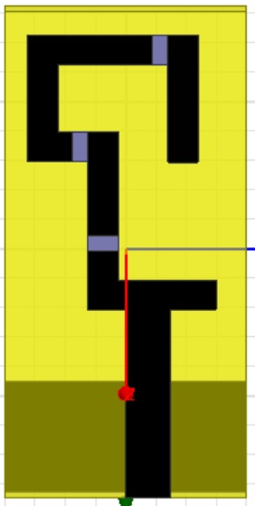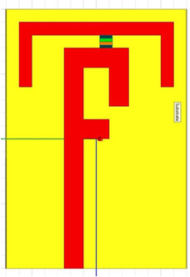
Fig 6 : Fabrication process done for frequency reconfigurable planar monopole antennas for wireless applications.

Analysis and performance

Simulation: Software like Computer Simulation Technology (CST) Microwave Studio Suite is used to simulate and optimize the antenna design before fabrication.
Switching states: The antenna operates in different modes depending on the state of the PIN diodes:
Mode 1 (e.g., switches OFF): Operates as a single band antenna (e.g., WLAN at 5.2 GHz).
Mode 2 (e.g., sw1 ON, sw2 OFF): Operates as a single band antenna (e.g., WiMAX at 3.59 GHz).
Mode 3 (e.g., sw1 OFF, sw2 ON): Operates as a dual-band antenna (e.g., 4.5 GHz and 6.22 GHz).
Mode 4 (e.g., both switches ON): Operates as a dual-band antenna (e.g., 2.45 GHz and 6.27 GHz).

Key performance metrics:
- Return Loss (\(S_{11}\)): Measures the power reflected from the antenna. A value of less than -10 dB generally indicates good impedance matching across the operating frequencies.
- Voltage Standing Wave Ratio (VSWR): Related to return loss, a VSWR value of less than 2 (ideally 1.5 or less in high-performance designs) across the operating bands indicates good matching to the feed line.
- Operating Frequency Bands: The antenna's ability to switch between desired frequency bands (e.g., 2.4 GHz, 3.5 GHz, 5.2 GHz for WLAN/WiMAX applications) is confirmed for different switch states.
- Gain: The maximum gain in dB is measured to assess the antenna's ability to direct power in a specific direction.
- Radiation Pattern: Far-field characteristics are measured in an anechoic chamber to confirm the pattern (e.g., omnidirectional in the H-plane and bidirectional in the E-plane for typical monopoles) and pattern stability across frequencies.
- Efficiency: The ratio of radiated power to input power, indicating overall performance and losses.
- Bandwidth: The impedance bandwidth (e.g., -10 dB bandwidth) for each operational mode is determined.

GRAPH-3.1
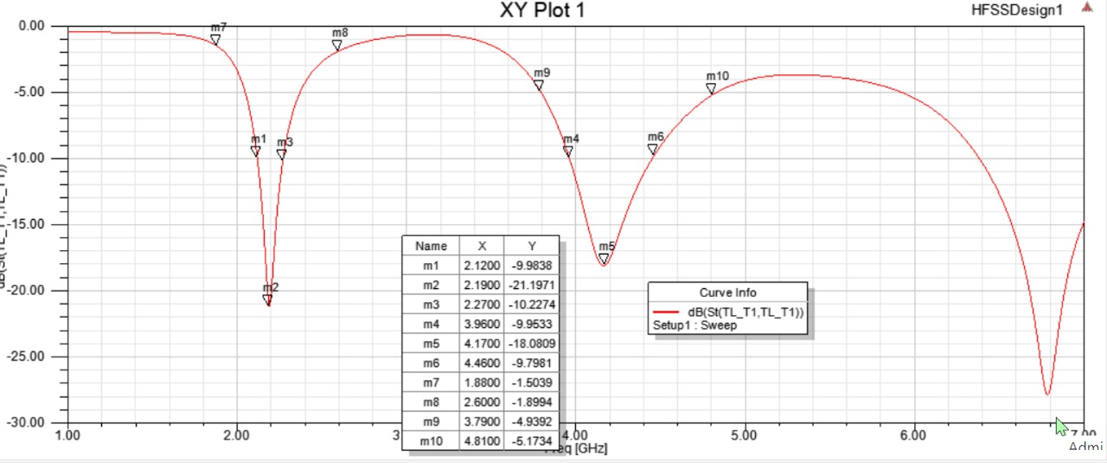
Fig1: ON state XY plot
Based on the plot and table markers, the device appears to have several resonant frequencies:
Around 2.12 GHz (m1, m2, m3) with return loss values around -10 dB to -21 dB.
Around 3.96 GHz to 4.46 GHz (m4, m5, m6) with values around -10 dB to -18 dB.
Around 4.81 GHz (m10) with a value around -5.17 dB.

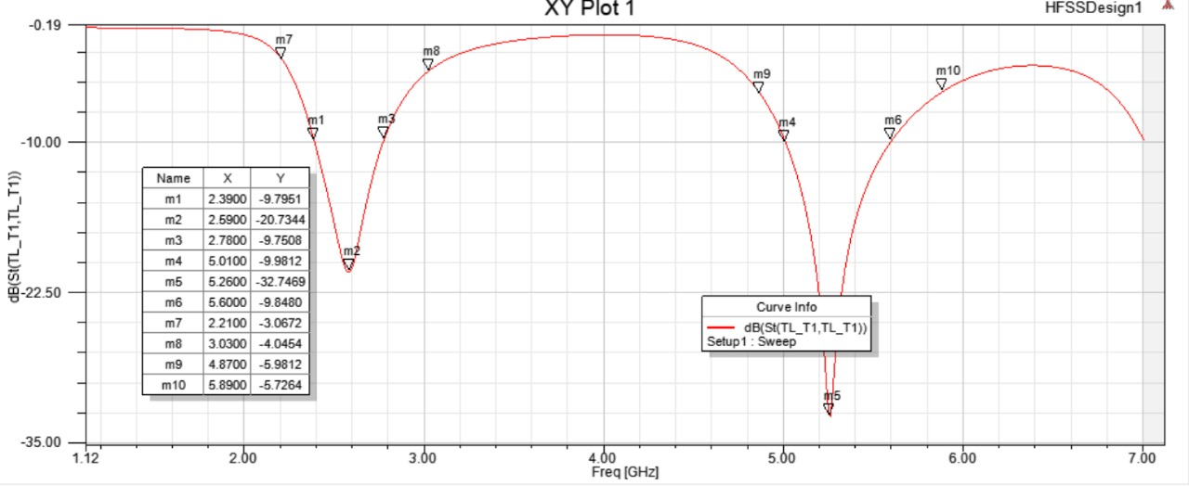
Fig2: OFF state XY plot
m7 at 2.2100 GHz has a return loss of -3.0672 dB.
m8 at 3.0300 GHz has a return loss of -4.0454 dB.
m9 at 4.8700 GHz has a return loss of -5.9812 dB.
m10 at 5.8900 GHz has a return loss of -5.7264 dB.

Graph 3.2
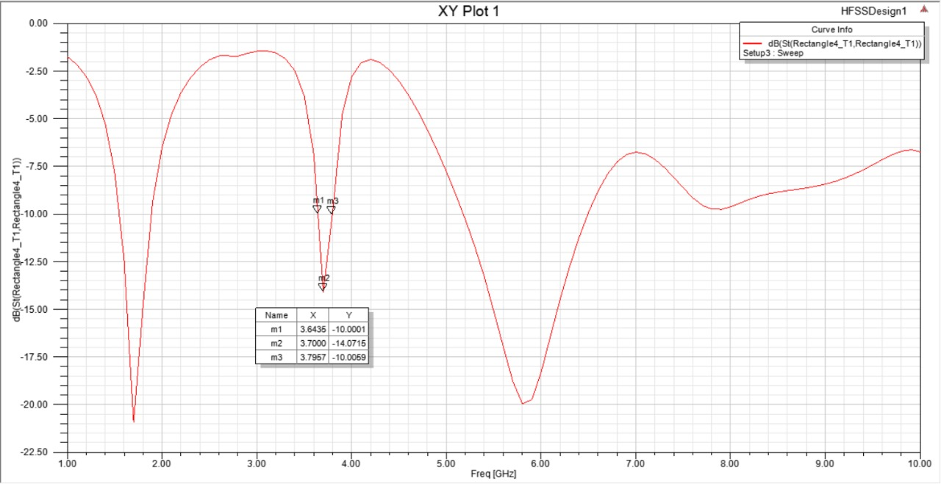
Fig: XY plot ON state
Markers m1 (3.6435 GHz, -10.0001 dB) and m3 (3.7957 GHz, -10.0059 dB) indicate the edges of this band where the return loss is approximately -10 dB. The lowest return loss in this band is approximately -14.07 dB at 3.7000 GHz (marker m2). A return loss of -10 dB or less is generally, the 3.64 GHz to 3.80 GHz range and the band around 1.7 GHz

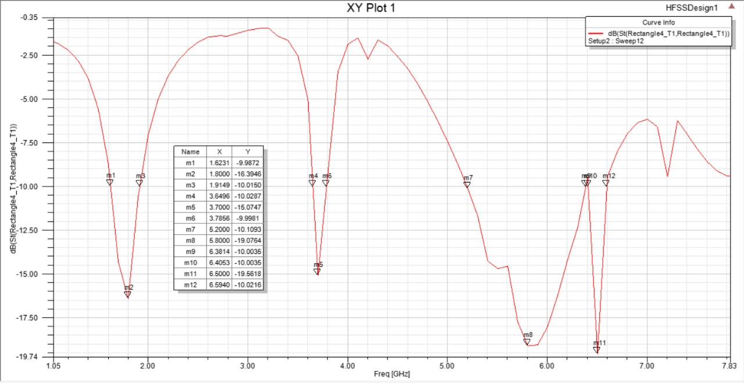
Fig: XY plot off state
The device exhibits multiple resonance frequencies (where the curve dips significantly), such as approximately 1.6 GHz, 1.9 GHz, 3.6-3.8 GHz, and 6.4-6.6 GHz.

4. CONCLUSIONS
The design and performance analysis of frequency reconfigurable planar monopole antennas lead to several key conclusions regarding their functionality and utility in modern wireless communication systems:
- Versatility: The primary conclusion is that these antennas offer exceptional versatility, enabling a single antenna to operate across multiple frequency bands or modes by electronically adjusting their physical configuration (e.g., using PIN diodes or MEMS switches).
- Compactness and Integration: The planar monopole design allows for a compact, low-profile, and lightweight structure that is easily integrated into portable and handheld devices like smartphones, laptops, and IoT terminals, addressing space constraints in modern electronics.
- Performance: Performance analysis confirms that these antennas can achieve good electrical characteristics, including acceptable gain, high radiation efficiency (often over 90%), low return loss, and stable radiation patterns (typically omnidirectional in the H-plane), across all their operational modes.
- Spectrum Efficiency and Interference Mitigation: By providing switched or continuous frequency tuning, these antennas can effectively use available spectrum resources and avoid interference with other communication bands that are not in use, which is a significant advantage for cognitive radio applications.
- Practicality: The research validates the practicality of using switching mechanisms (like PIN diodes and integrated bias circuits) to dynamically control the antenna's effective length and thus its resonant frequency, with good agreement between simulated and measured results.
In essence, frequency reconfigurable planar monopole antennas provide an effective and adaptable solution for the complex, multi-frequency demands of current and future wireless communication standards (like WLAN, WiMAX, and 5G sub-6 GHz).
6. REFERENCES
1)Md.SohelRana and Md.Mostafizur Rahman (2021) .Study of Micro Strip patch antenna for wireless communication system.
2)International Journal of Engineering Research & Technology (IJERT) Vol. 3 Issue 8, August - 2014 IJERT ISSN: 2278-0181
3)https://ieeexplore.ieee.org/document/8609703
4)Design and Analysis of Microstrip Patch Antenna Arrays, Ahmed Fatthi Alsager, ahmed4912@yahoo.com
5)Balanis, C. (2005). Antenna Theory and Desig. Canada: Jhon Wiley & Sons, Inc, 3rd edition.
6)Stutzman, W. a. (1998). Antenna Theory and Design. Jhon Wiley &Sons,Inc.
7)D. M. Pozar and D. H. Schaubert (1995). Microstrip Antennas:In The Analysis and Design of microstrip Antennas and Arrays. IEEE Press.
8)Gardiol, F. E. (n.d.). Broadband Patch Antennas. Artech House.
9)Lee, E. K. (1997). Advances in Microstrip and Printed Antennas. Jhon Wiley.
10)P. B. I. B. a. A. R. Garg, Ittipiboon. (2000). Microstrip Antenna Design Handbook. Artech House.
11)Punit S. Nakar. (2004). Thesis on Design of a compact microstrip patch antenna for use in wireless (cellular devices)

